**WEEK 1**

NAME: ROHIT KARUKOLA

SUPERSETID: 6383975

**Exercise 1: Implementing the Singleton Pattern**

**Scenario:**

You need to ensure that a logging utility class in your application has only one instance throughout the application lifecycle to ensure consistent logging.

**Steps:**

1. **Create a New Java Project:**
   * Create a new Java project named **SingletonPatternExample**.
2. **Define a Singleton Class:**
   * Create a class named Logger that has a private static instance of itself.
   * Ensure the constructor of Logger is private.
   * Provide a public static method to get the instance of the Logger class.
3. **Implement the Singleton Pattern:**
   * Write code to ensure that the Logger class follows the Singleton design pattern.
4. **Test the Singleton Implementation:**

Create a test class to verify that only one instance of Logger is created and used across the application.

**CODE:**

**public class Main {**

**public static void main(String[] args) {**

**Logger logger1 = Logger.getInstance();**

**Logger logger2 = Logger.getInstance();**

**logger1.log("This is the first log message.");**

**logger2.log("This is the second log message.");**

**if (logger1 == logger2) {**

**System.out.println("Both logger1 and logger2 refer to the same instance.");**

**} else {**

**System.out.println("Different instances exist!");**

**}**

**}**

**}**

**// Singleton Class**

**class Logger {**

**private static Logger instance;**

**private Logger() {**

**System.out.println("Logger initialized.");**

**}**

**public static Logger getInstance() {**

**if (instance == null) {**

**instance = new Logger();**

**}**

**return instance;**

**}**

**public void log(String message) {**

**System.out.println("[LOG]: " + message);**

**}**

**}**

**OUTPUT:**

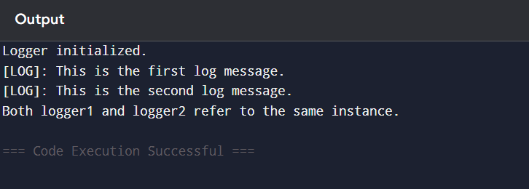

**Exercise 2: Implementing the Factory Method Pattern**

Scenario:

You are developing a document management system that needs to create different types of documents (e.g., Word, PDF, Excel). Use the Factory Method Pattern to achieve this.

Steps:

1. Create a New Java Project:
   * Create a new Java project named FactoryMethodPatternExample.
2. Define Document Classes:
   * Create interfaces or abstract classes for different document types such as WordDocument, PdfDocument, and ExcelDocument.
3. Create Concrete Document Classes:
   * Implement concrete classes for each document type that implements or extends the above interfaces or abstract classes.
4. Implement the Factory Method:
   * Create an abstract class DocumentFactory with a method createDocument().
   * Create concrete factory classes for each document type that extends DocumentFactory and implements the createDocument() method.
5. Test the Factory Method Implementation:

Create a test class to demonstrate the creation of different document types using the factory method.

public class Main {

public static void main(String[] args) {

DocumentFactory wordFactory = new WordFactory();

Document wordDoc = wordFactory.createDocument();

wordDoc.open();

DocumentFactory pdfFactory = new PdfFactory();

Document pdfDoc = pdfFactory.createDocument();

pdfDoc.open();

DocumentFactory excelFactory = new ExcelFactory();

Document excelDoc = excelFactory.createDocument();

excelDoc.open();

}

}

// Step 1: Document Interface

interface Document {

void open();

}

// Step 2: Concrete Document Classes

class WordDocument implements Document {

public void open() {

System.out.println("Opening Word Document");

}

}

class PdfDocument implements Document {

public void open() {

System.out.println("Opening PDF Document");

}

}

class ExcelDocument implements Document {

public void open() {

System.out.println("Opening Excel Document");

}

}

// Step 3: Abstract Factory

abstract class DocumentFactory {

public abstract Document createDocument();

}

// Step 4: Concrete Factories

class WordFactory extends DocumentFactory {

public Document createDocument() {

return new WordDocument();

}

}

class PdfFactory extends DocumentFactory {

public Document createDocument() {

return new PdfDocument();

}

}

class ExcelFactory extends DocumentFactory {

public Document createDocument() {

return new ExcelDocument();

}

}

OUTPUT:

